[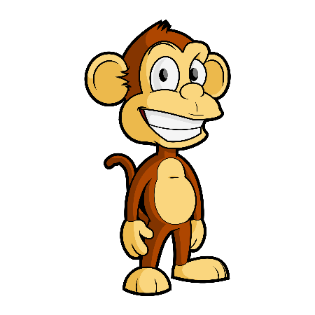](https://www.google.be/url?sa=i&rct=j&q=&esrc=s&source=images&cd=&cad=rja&uact=8&ved=0ahUKEwjQ1Zig98zLAhWB1xQKHQjPDN4QjRwIBw&url=http://e2ua.com/group/picture-cartoon/&psig=AFQjCNEFuTnN-VgDhf-MsrVZIPLmaa0Vjw&ust=1458483143520914)

Naam: …………………………………………………

Optellen tot 20

. + .

. + .

4 + 9 = + . = . 8 + 6 = + . = .

. . . .

. + .

. + .

5 + 7 = + . = . 9 + 9 = + . = .

. . . .

. + .

. + .

8 + 5 = + . = . 3 + 8 = + . = .

. . . .

. + .

. + .

6 + 7 = + . = . 9 + 8 = + . = .

. . . .

+ 9 = . + 8 = . + 7 = .

6

.

3

.

4

.

. . .

+ 6 = . + 3 = . + 9 = .

5

.

9

.

7

.

. . .

+ 8 = . + 9 = . + 7 = .

6

.

3

.

7

.

. . .

+ 8 = . + 4 = . + 7 = .

8

.

7

.

5

.

. . .

8 + 4 = . 5 + 6 = .

. . . .

9 + 7 = . 7 + 6 = .

. . . .

5 + 7 = . 4 + 9 = .

. . . .

9 + 9 = . 3 + 8 = .

. . . .